**CMPE 352 – Signal Processing & Algorithms**

**Problem Session3   
Week of 4 March 2019**

**Problem 1**

Consider the triangle signal with period $T$:

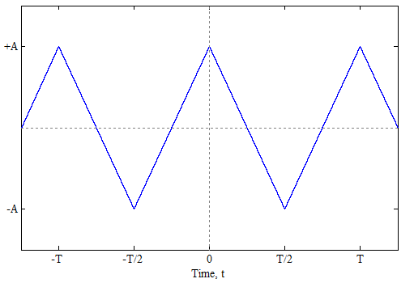

1. Find $a_{0 }$, $A_{k}$ and $θ_{k}$ to obtain the trigonometric Fourier series expansion $a_{0}+2\sum_{ı=1}^{∞}{A_{k}\cos{(kω_{0}t+θ_{k})}}$ of this signal.
2. Find $a_{k }$ to obtain the exponential Fourier series expansion $\sum_{k=-∞}^{∞}{a_{k}e^{jkω_{0}t}}$ of this signal.
3. Compare the results obtained

**Problem 2**

1. Write a Matlab code that allows computing $A_{k}$ and $θ_{k}$ (in the Fourier series expansion) for any $k$.
2. Plot the Fourier series expansion for the fundamental component only:

$2A_{1}\cos{(ω_{0}t+θ_{1})}$

1. Plot the Fourier series expansion for the fundamental + the 2nd harmonic:

$2A_{1}\cos\left(ω_{0}t+θ_{1}\right)+2A_{2}\cos{({2ω}_{0}t+θ_{2})}$

1. Plot the Fourier series expansion up to the 5th harmonic:
$$2A_{1}\cos\left(ω_{0}t+θ_{1}\right)+2A_{2}\cos\left({2ω}_{0}t+θ_{2}\right)+…+2A_{5}\cos\left({5ω}_{0}t+θ_{5}\right)$$

2. Plot the Fourier series expansion up to the 20th harmonic.